Parsons
Parsons Constructors Inc.
100 West Walnut • Pasadena. California 91124 • (626) 440-3000 • Fax: (626) 440-2516

July 15, 2016

Southland Electric inc.
Attn: Tim Dunbar, Project Manager
4950 Greencraig lane
San Diego, CA 92123

Hello Mr. Dunbar,

Congratulations on the recent contract award of the Installation of i21 Classroom Tecnology Systems IDIQ CZ-17-0079-08..

To give you some background on these meetings, the general contractor is required by PSA Articles 8 and 16 to conduct a PSA Pre-job Conference with the local construction unions. Both meetings must occur at least two weeks prior to the start of construction and we request that you have all subcontractors regardless of tier, present at the Pre-job Conference. All contractors working on this project are also encouraged to attend one of the District's PSA 101 Training Seminars. The purposes' of the Pre-job Conference meetings are as follows:

• The general contractor will disclose union work assignments for each scope of work to be performed.
This will help all parties confront and resolve any union jurisdictional disputes prior to work commencing.
• The general contractor will distribute detailed project information and a subcontractor listing to all present, establishing open communication between labor and management prior to work commencing.
• The District will review its employment and contracting programs and goals, including the employment of District residents at PSA-covered projects.

Please be prepared to distribute completed copies of the Pre-job Conference form to all present at the Pre­ job Conference. I will request a completed copy of the Pre-job Conference form a few days prior to the Pre­ job Conference so we may review it.

We will be present for the Pre-job Conference, but a Southland Electric inc project manager or other assigned employee will be asked to review the Pre-job Conference form in detail. Also, please ensure that you and all of your subcontractors sign and submit a PSA Letter of Assent prior to the commencement of any site work.

Our office has scheduled the required Pre Job Conference meeting for Wednesday July 27 2016 1:00pm .

Location:
PPO Training Room A
4860 Ruffner Street
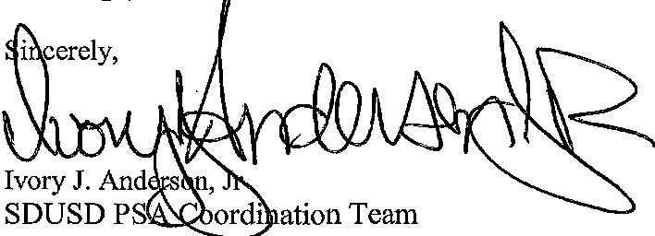
San Diego, CA 92 111

Parsons Constructors Inc.

cc: George Harris Ill/SDUSD (gharris@sandi.net)

